|  |  |
| --- | --- |
| **Subject** | **OPR for the helpdesk Ticketing system** |
| **Department** | **IT Support** |
| **Recorder** | **Tharindu Chinthaka** |
| **Approved by** |  |
| **Create Date** | **16/01/2019** |
| **Last Update** |  |
| **Path on Network Location** | [**Click Here**](https://cisintlcom.sharepoint.com/itsupport/_layouts/15/guestaccess.aspx?docid=13e89ff855b234ad8a82bed2dc255847d&authkey=AaSTmOvgmk9kdxHV3fGhKzM&expiration=2018-07-11T04%3A10%3A14.000Z&e=CunSYQ) |
| **No. of Pages Including this page** | **13** |

**Introduction**

**User Level**

1. **How to create a ticket.** 
   1. **Method 01 - Create a ticket using email.**
   2. **Method 02 - Create a ticket using web portal.**
2. **Update/commenting on a ticket**

**Admin Level**

1. **Log in to Helpdesk as an admin**
2. **Dashboard**
3. **Assign Ticket**
4. **CC Users**
5. **Update Tickets / Comment on a ticket**
6. **Close Tickets**
7. **Create Category**
8. **Create users**
9. **Email tags**
10. **Reports**

**Introduction**

1. **What Is the Purpose of Help Desk?**

**The principal purpose of help desk is making sure that technical issues and customer concerns are quickly addressed and resolved. Issues are also easily prioritized by category, allowing professionals to engage in multitasking. When needed, help desk can customize tickets so that more detailed information is collected, and issues categorized for convenience. Such tools can automatically assign issues by analyzing tickets. These can be assigned to relevant staff who may be more adept in handling certain issues than others.**

1. **What is the help desk?**

**Help Desk refers to a breed of software solutions, which involves all apps and systems that businesses use to respond to customer queries and concerns in the shortest possible time.**

1. **What Are the Benefits of Using Help Desk?**

Now that you know what the purpose of help desk is, it is just as important to know how such solution can benefit a business. The following are but some of help desk’s benefits:

* Automation of customer services
* Productivity and issue tracking
* Better view of customers’ data
* Improved asset management
* Better scalability of infrastructure
* Minimizes issue resolution time

User Level

In this OPR We are using following details

Helpdesk Email [rdservice@eteknowledge.com](mailto:rdservice@eteknowledge.com)

Helpdesk URL <https://tekssrd.on.spiceworks.com>

Helpdesk Portal <https://tekssrd.on.spiceworks.com/portal>

1. How to create a ticket.
   1. Method 01 - Create a ticket using email.

Send the email to the **Helpdesk email** ([rdservice@eteknowledge.com](mailto:rdservice@eteknowledge.com))

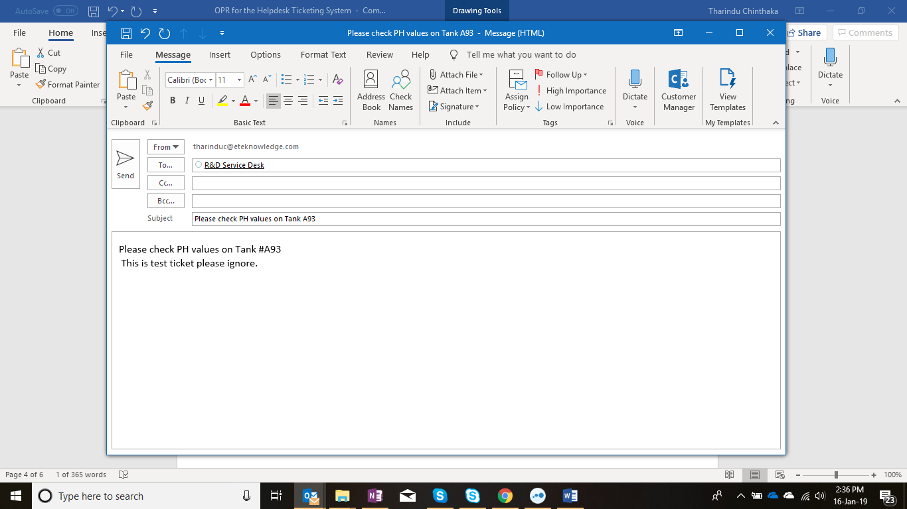

**4**

**1**

**2**

**3**

* 1. Helpdesk Email Address
  2. Task or Issue – This will show as ticket Subject
  3. More details about task or issue – This will show as Ticket content
  4. Attachment – You can attach the excel file/Screenshot.
  5. Once you send the email to Helpdesk portal you will receive notification email with **Ticket Number**.

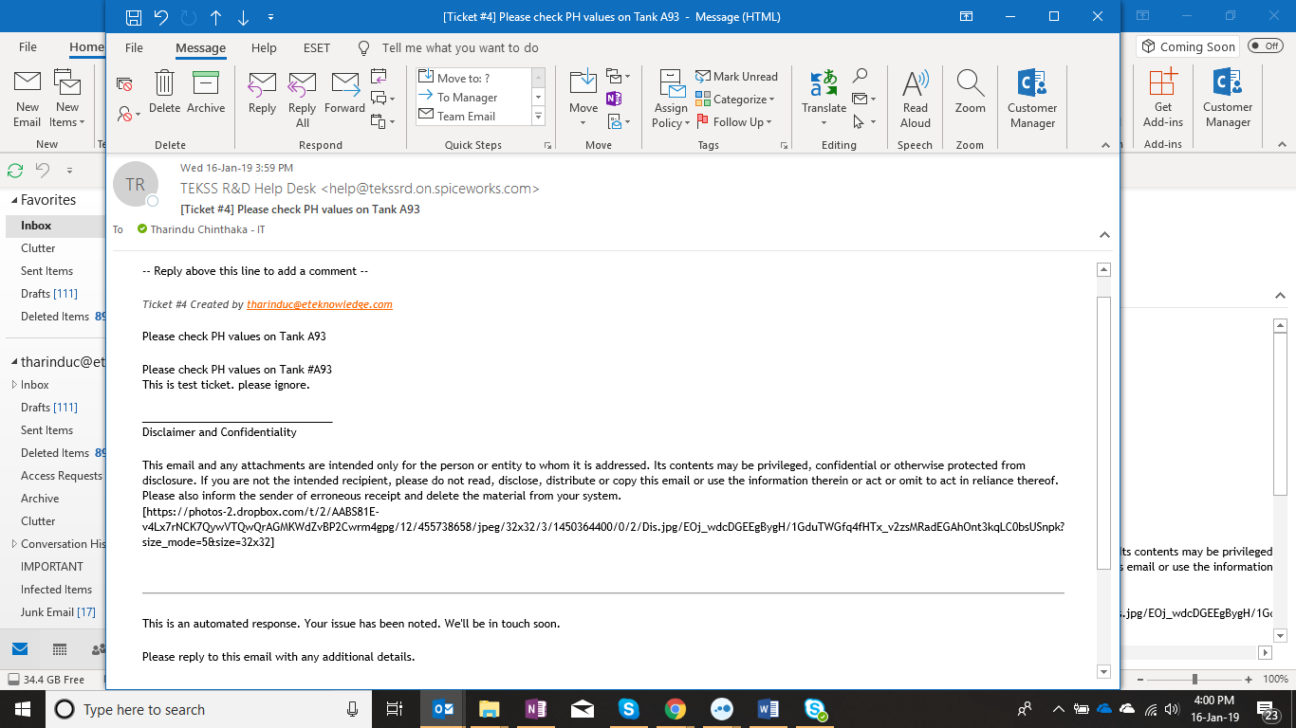

**5**

* 1. Method 02 - Create a ticket using web portal.
  2. Log in to Portal web portal - <https://tekssrd.on.spiceworks.com/portal>
  3. Enter Your Email
  4. Task or Issue – This will show as ticket Subject
  5. More details about task or issue – This will show as Ticket content
  6. If there any attachment you can attached here
  7. Type all details and click “**submit**” button
  8. Once you send the email to Helpdesk portal you will receive notification email with **Ticket Number**.

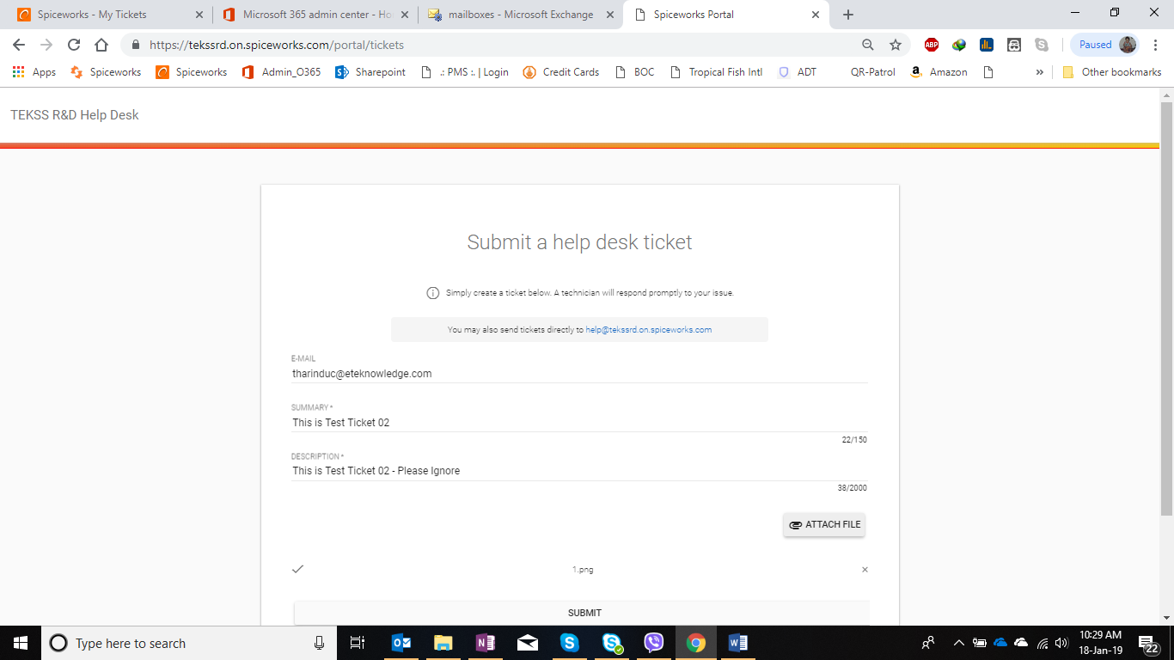

**6**

**7**

**8**

**9**

**10**

**11**

1. **Update / commenting on a ticket**
   1. Open the ticket notification email click “reply all” Button

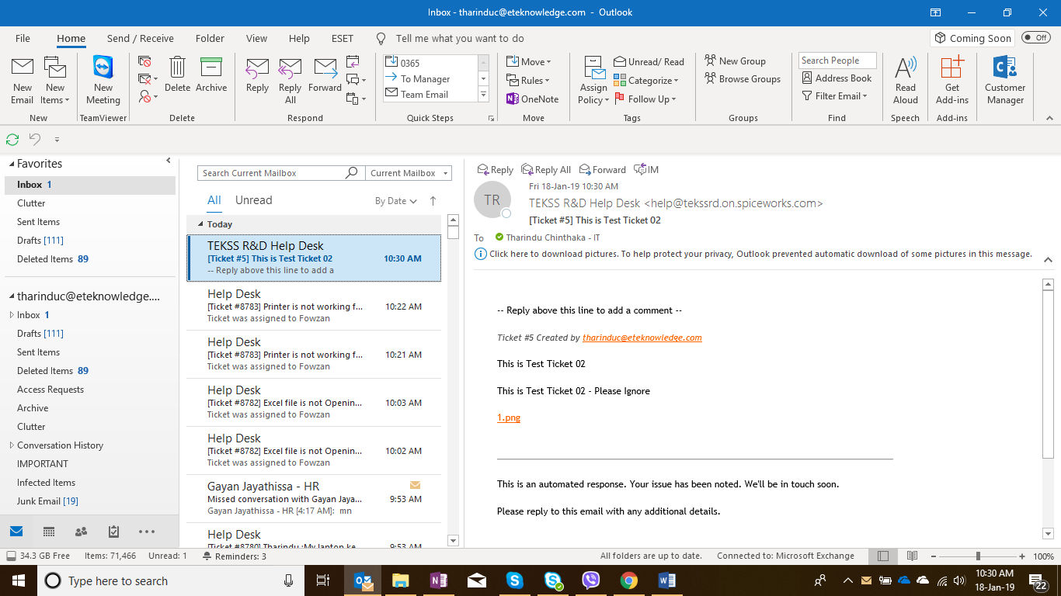

**13**

* 1. Type your comment in the email body
  2. click “Send”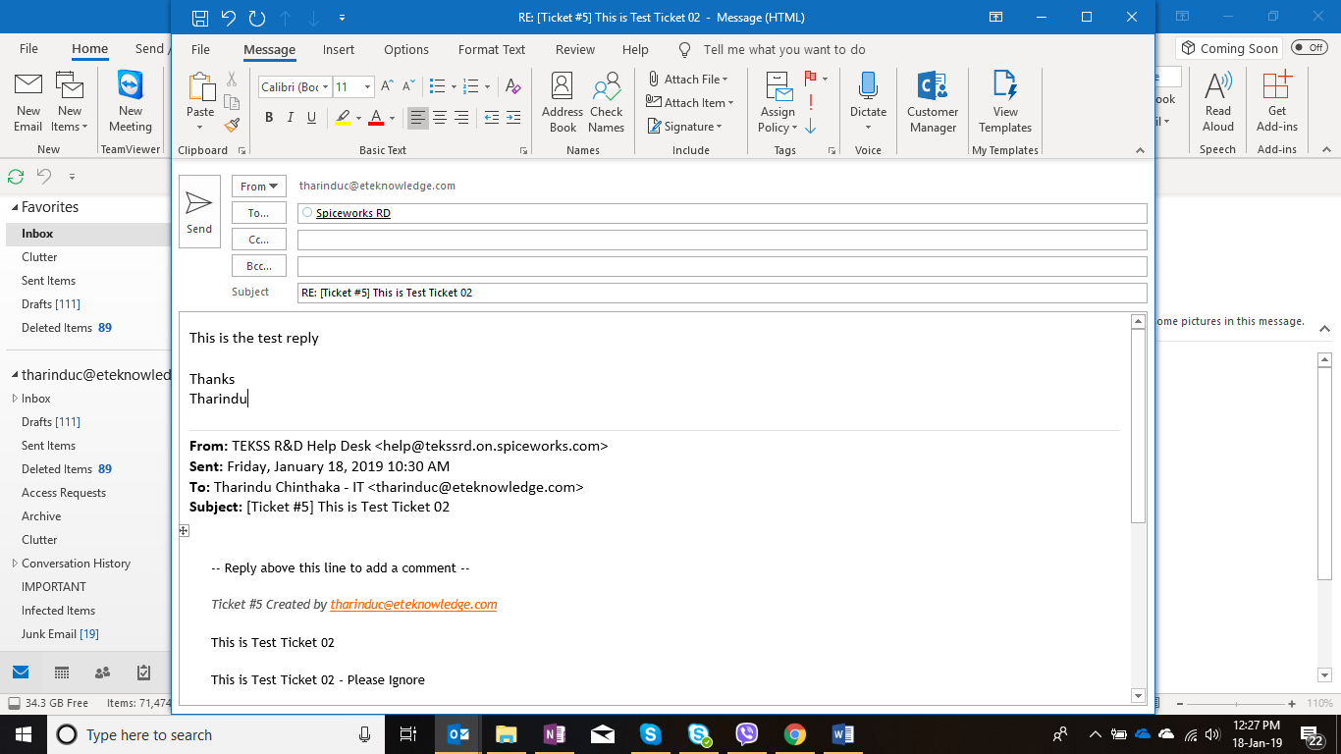

**15**

**14**

**13**

Admin Level

1. Log in to Helpdesk as an admin
2. Enter helpdesk URL - <https://tekssrd.on.spiceworks.com>
3. Enter admin username - [rdservicedeskspice@eteknowledge.com](mailto:rdservicedeskspice@eteknowledge.com)
4. Enter password
5. Click “**Login**” Button

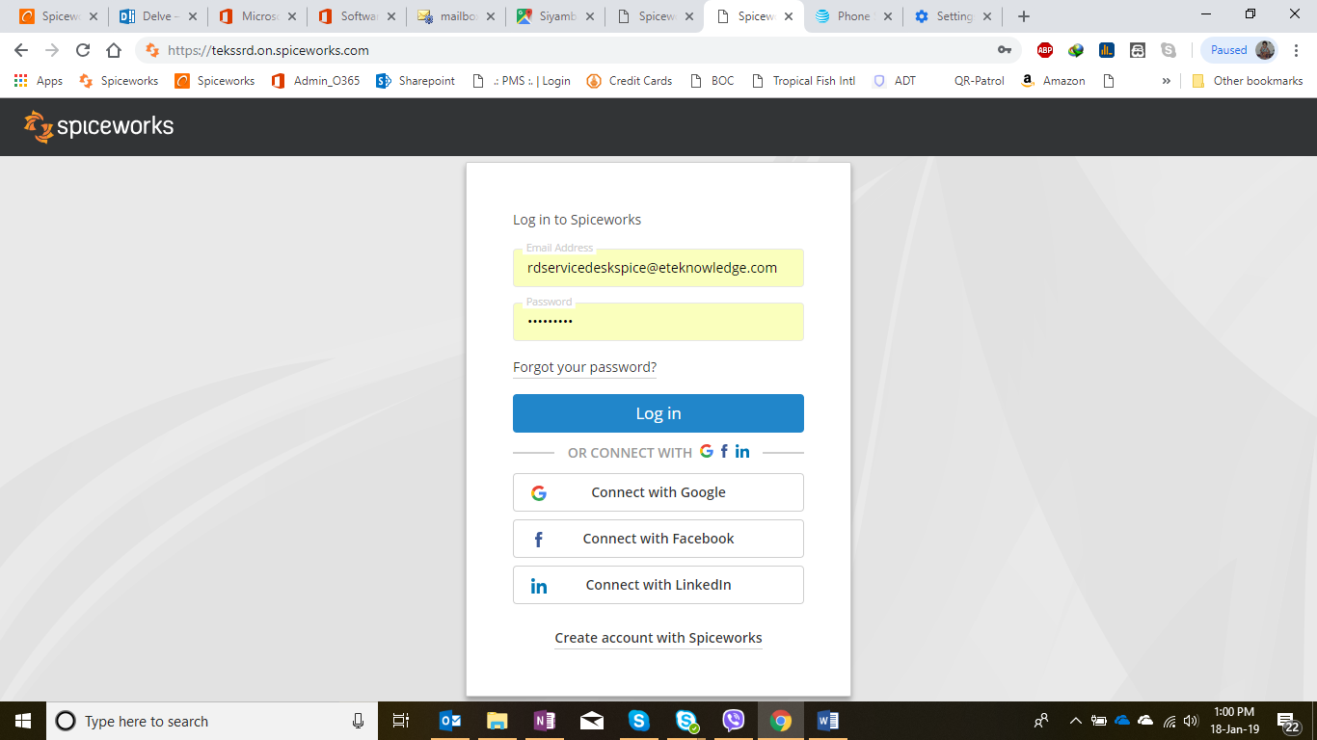

**1**

**2**

**3**

**4**

1. Dashboard
2. Assign Ticket
3. CC Users
4. Update Tickets
5. Close Tickets
6. Create Category
7. Create users
8. Email tags
9. Reports
10. Dashboard and Navigation
11. Dashboard
12. Current tickets
13. Admin Setting
14. Current ticket summary

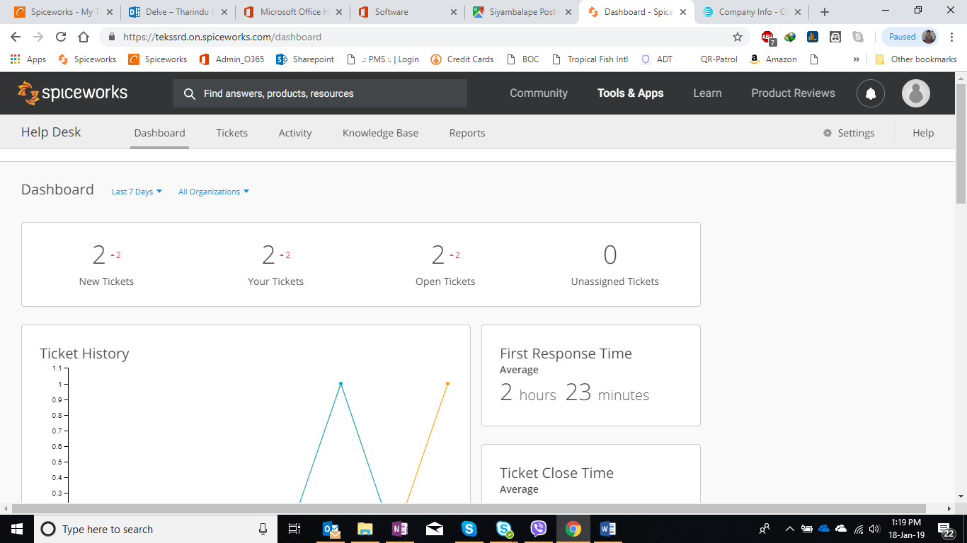

**6**

**5**

**7**

**8**

1. Assign Ticket and add category
2. Select the ticket
3. You can click here and assign ticket to you or someone in the department.
4. You can Change category here
5. Change due date

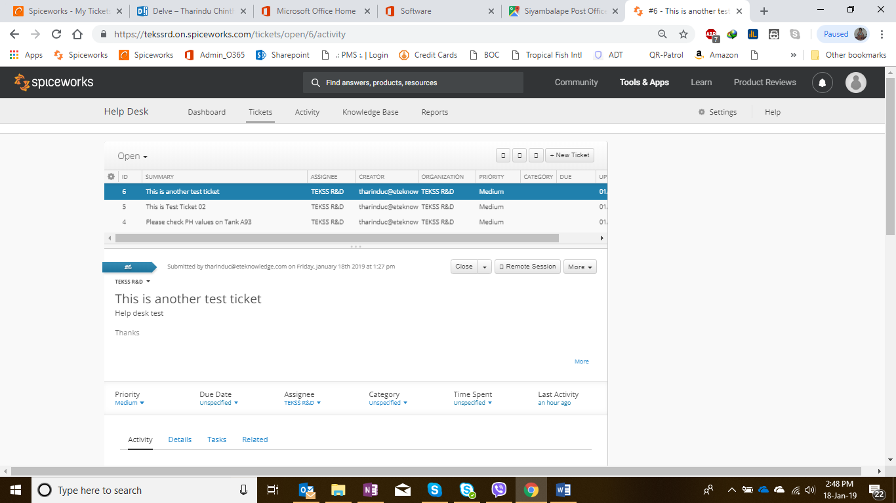

**9**

**10**

**12**

**11**

1. CC users / send ticket updates to another users
2. Click “**details**”
3. Type email address and press enter key

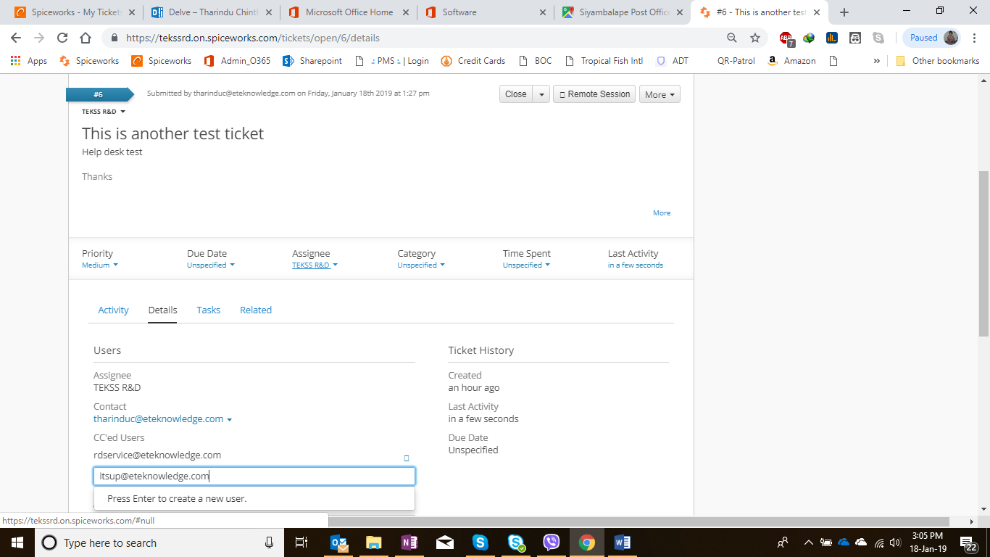

**13**

**14**

1. Update / Comment on a ticket
2. Select ticket and click “**Activity**” tab
3. Type here what you want to update
4. You can attach file from here
5. Click “**save**” button

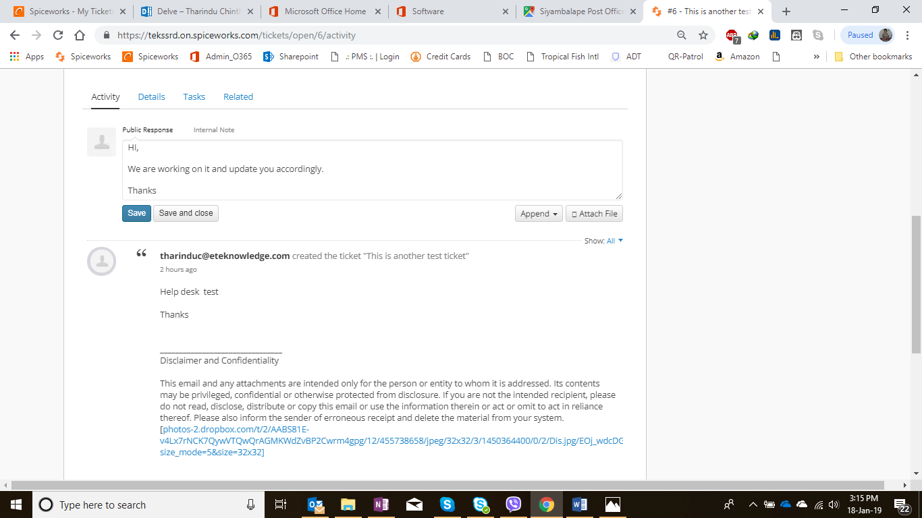

**15**

**16**

**17**

**18**

1. Close the ticket.

19. Select the ticket that you want to close

20. click the “**close**” button

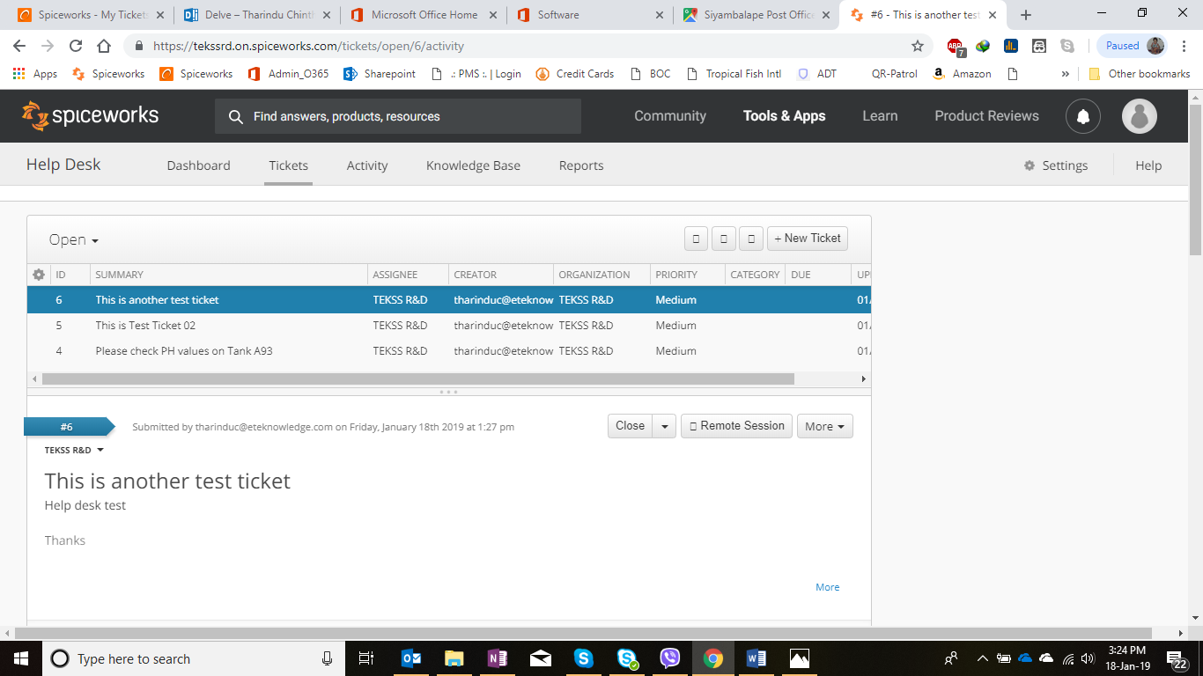

**19**

**20**

1. Create a category

21. click “**Settings**”

22. click “**ticket categories** “

23. Click **“+ category**”

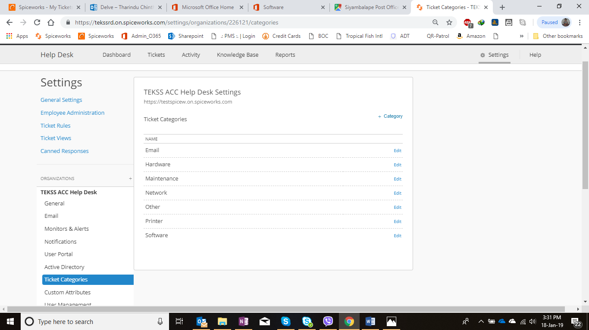

**21**

**22**

**23**

24. Type the category you want to create.

25. Click “**add category**” button.

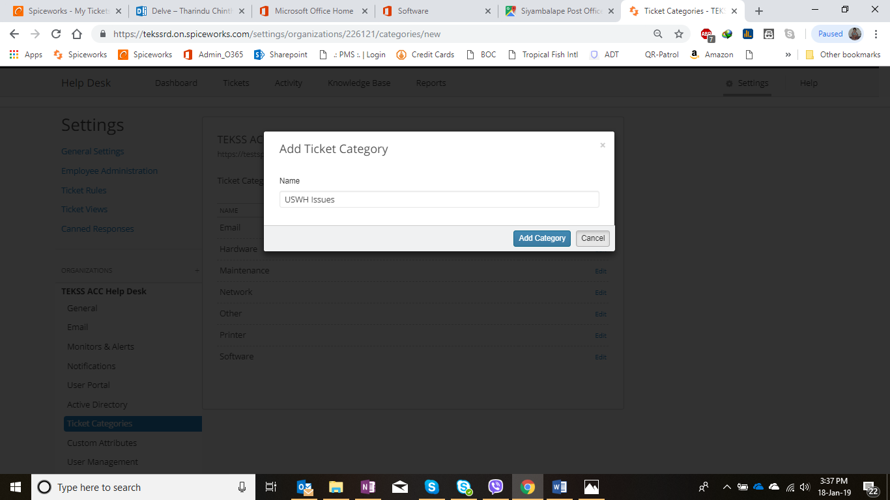

**24**

**25**

1. Create users / Remove users

26. Click “**Settings**”

27. Click “**Employee Administration**”

28. Click “**+Administrator**”

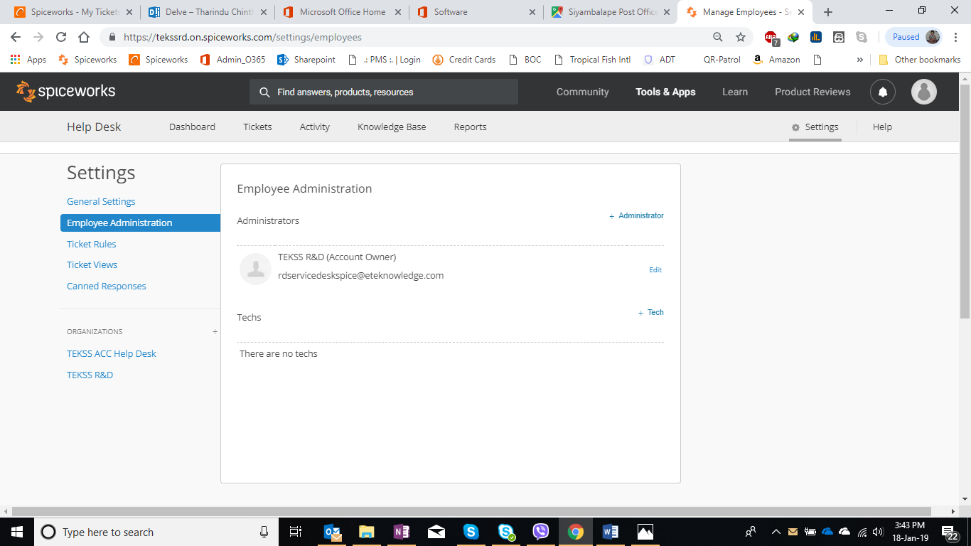

**27**

**26**

**28**

**24**

04

29. Type first name and Last name of the employee.

30. Type employees email address correctly.

31. Click “**save**”

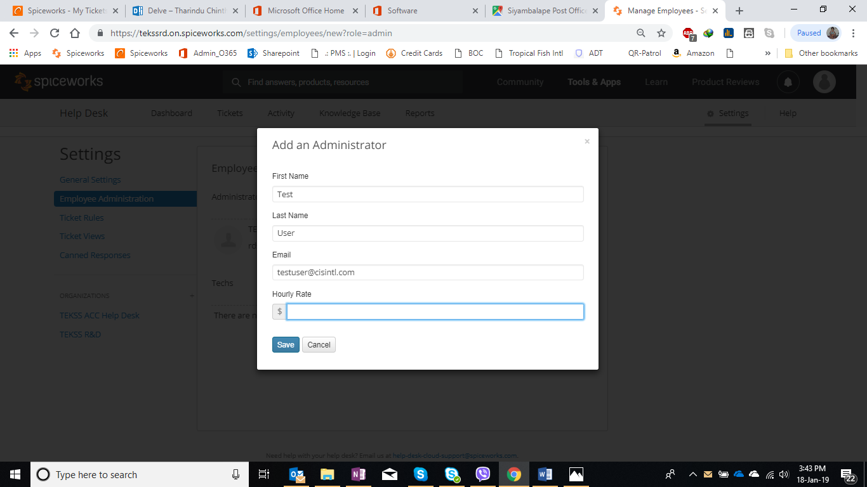

**29**

**30**

**31**

1. Email Hash Tags and how to use

**Add time worked to a ticket:**

#worked 10m

#add 2h to tharinduc@eteknowledge.com

#add 2h30m

**Notify a user:**

#notify testuser@cisintl.com

**Set ticket priority:**

#priority high

#priority low

**Close a ticket:**

#close

**Set due date:**

#due 3 weeks from today

#due tomorrow @5pm

#due July 15, 2013 at noon

#due 3 businessdays from today @ noon

**Assign the ticket:**

#assign to testuser

#assign testuser@cisintl.com

**CC a user (user must exist in your ticketing system):**

#cc Ford

#cc testuser@cisintl.com

**Accept a ticket:**

#accept

#assign to me

**Create a ticket for someone else:**

#created by testuser@cisintl.com

**Categorize the ticket:**

#category USWH

**Reopen a closed ticket:**

#reopen

32. You can type hash tags on email body

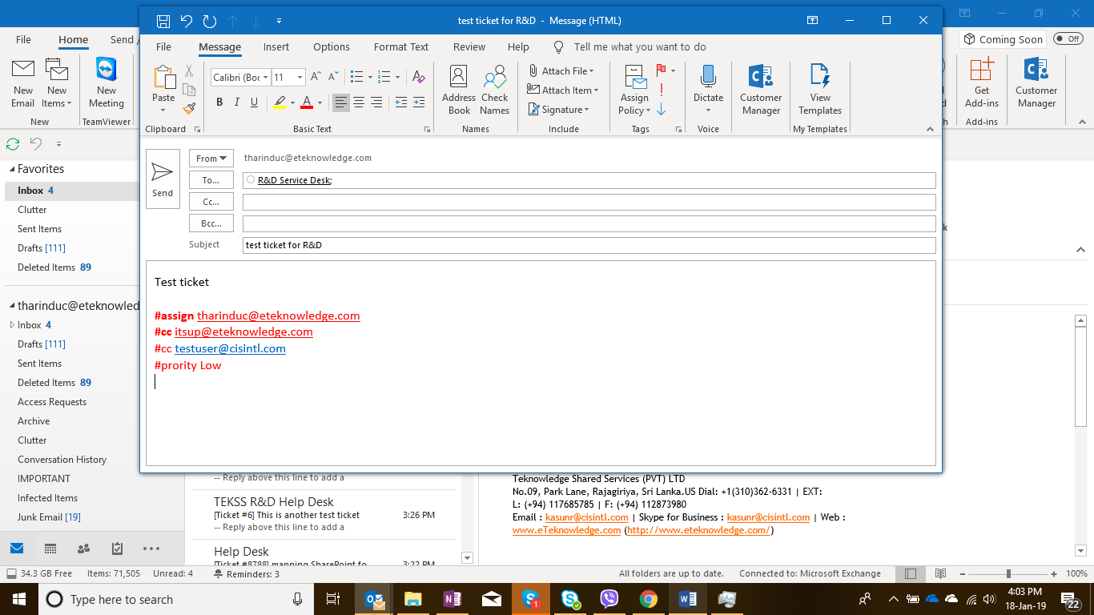

**32**